**Introduction:-**

In this lab we will create a Flexible app service at GCP App Engine using code. Here we will first test the code in our local pc and then deploy it to GCP App Engine. We will test the application and also check the underline infra being used for this app.

1. Extract “inventorybaseline” zip folder and copy inventory folder to ReadIt folder

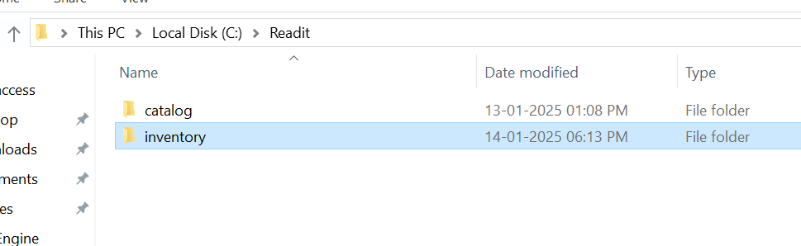

1. Open this folder to the vscode, and also in vscode go to view>command palate and run .net Generate Assets…… like earlier

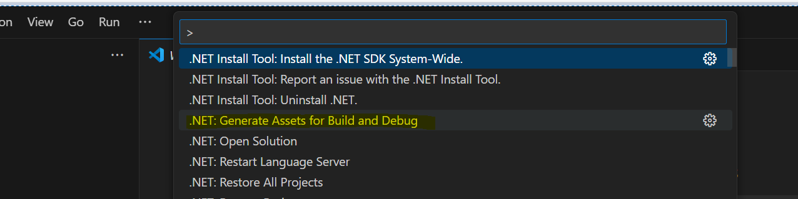

1. If see pop-up regarding debug missing, click yes  
   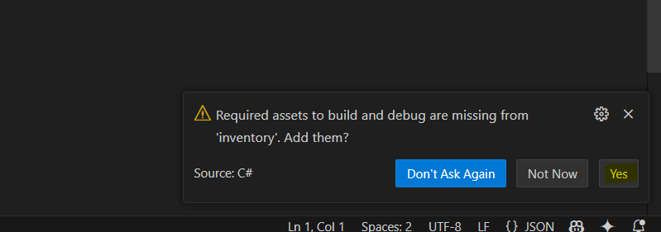
2. Also make sure target framework is net8.0 in inventory.csproj file  
   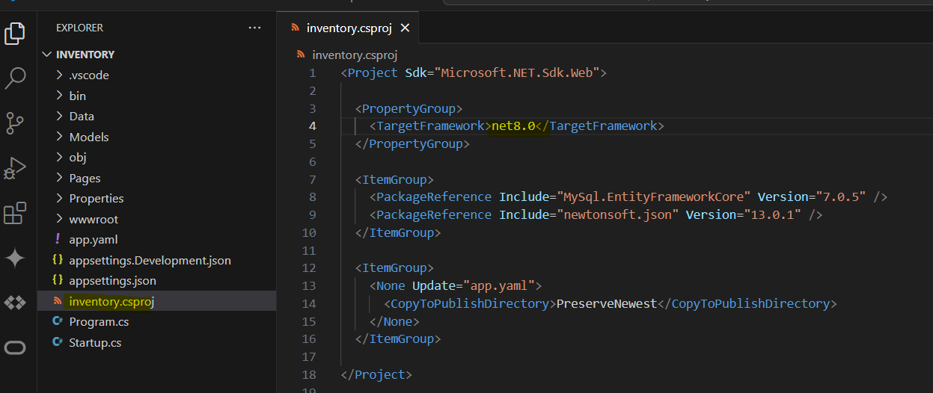
3. Press F5 to run the code, once it completes it should open the inventory webpage  
   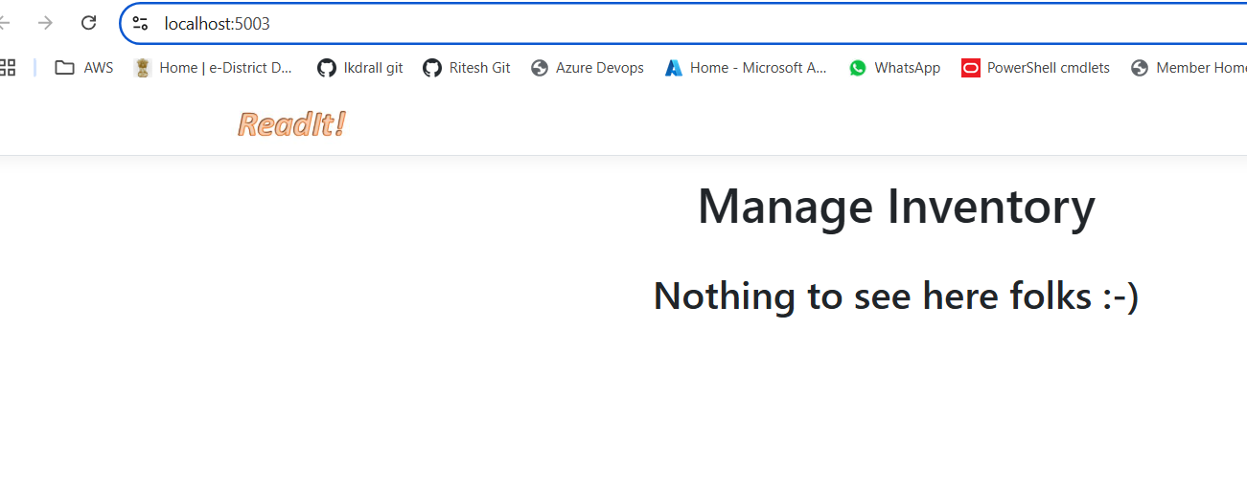
4. In vscode, can optionally go to Index.cshtml file under pages to see the code
5. Go to cloud code in vscode and click install google cloud cli  
   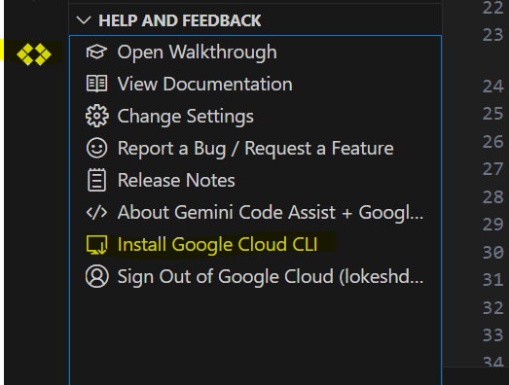
6. If see below error  
   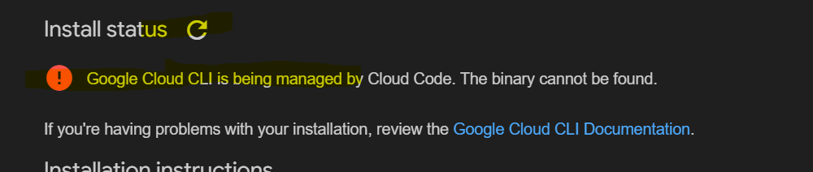
7. First turn **off** manage dependencies, then click download installer  
   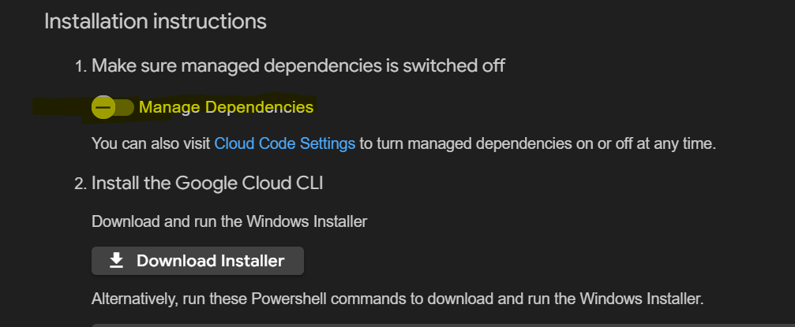
8. This will ask to download the installed from browser, download and run it as administrator.  
   Install the installer, also make it for **all user**.
9. Follow all installing instructions by keeping default, after finish when ask to configure, say **y**, select your project and say **n** when ask to set default regions
10. Restart vscode
11. (**Error**) In case see an error saying like “gcloud : File C:\Program Files (x86)\Google\Cloud SDK\google-cloud-sdk\bin\gcloud.ps1 cannot be loaded. The file C:\Program Files (x86)\Google\Cloud SDK\google-cloud-sdk\bin\gcloud.ps1 is not digitally signed…….” , then open powershell via admin and run below command  
    Set-ExecutionPolicy -ExecutionPolicy Unrestricted
12. Run gcloud config get-value project to confirm your project is selected  
    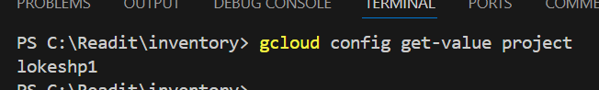
13. Copy app.yaml file and paste it to the inventory folder under ReadIt. Once copied, it will get visible to vscode as well
14. Click app.yaml file and read its details
15. Run gcloud app deploy -v v1 (here this name v1 can be anything as we want to keep for version name) command at vscode
16. Now go to gcp and under services, there will be new entry named inventory (or same name as mentioned at “service” in app.yaml file  
    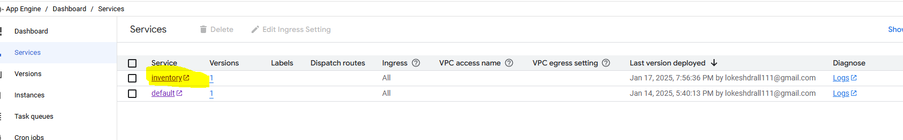
17. Now click “inventory” service name, and it should open the inventory page  
    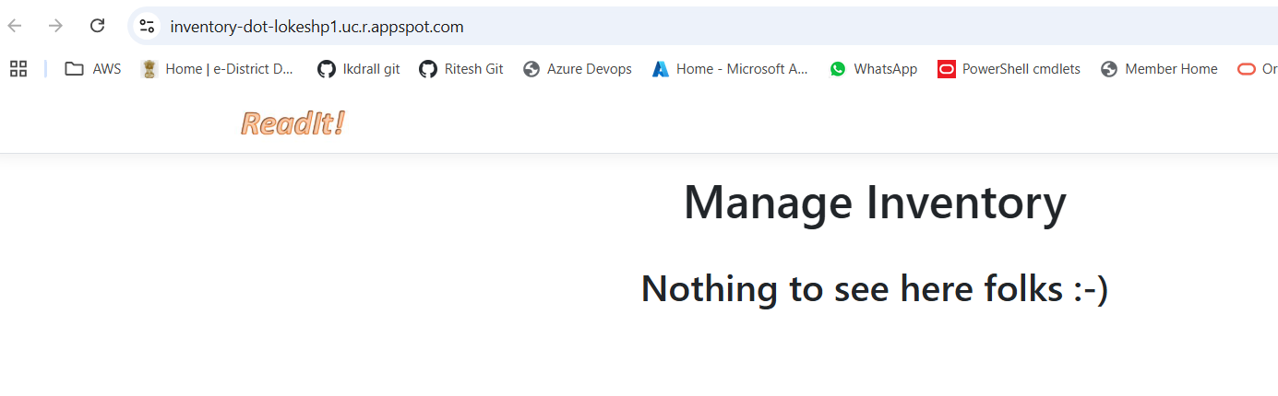
18. Go to versions, select inventory and you will see the version name (v1) as we put in in app.yaml file while running the app deploy command in, also see environment as Flexible  
    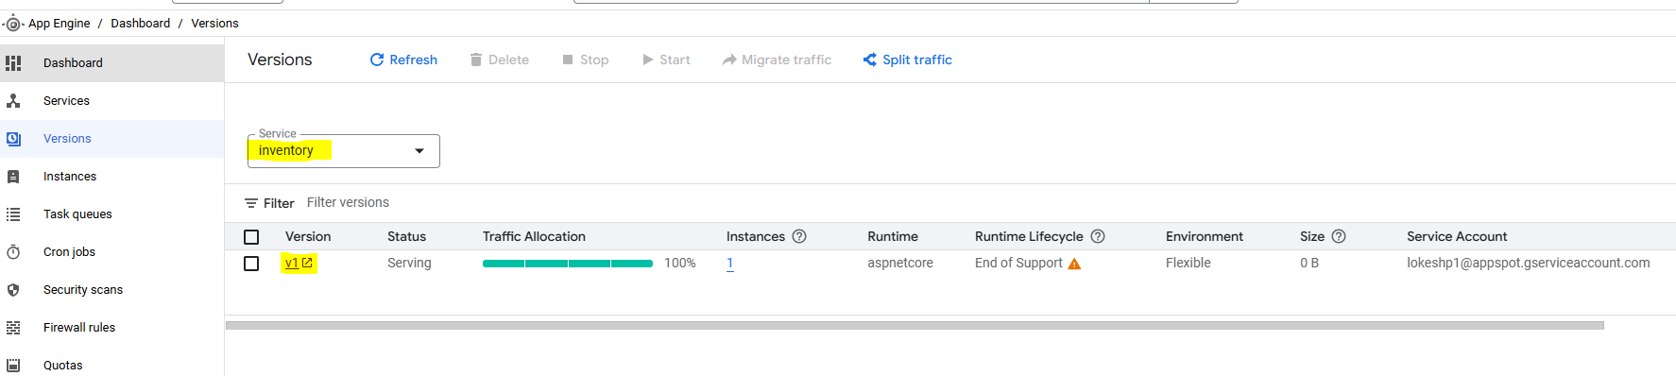
19. Click at instance
20. This will show all details related to the infra running underline  
    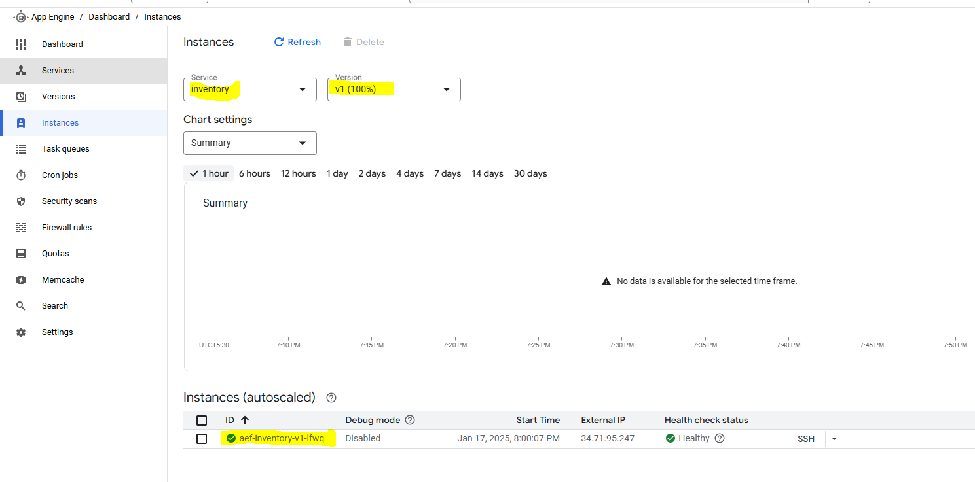
21. Also verify version data, it would be similar to what we gave in app.yaml file  
    